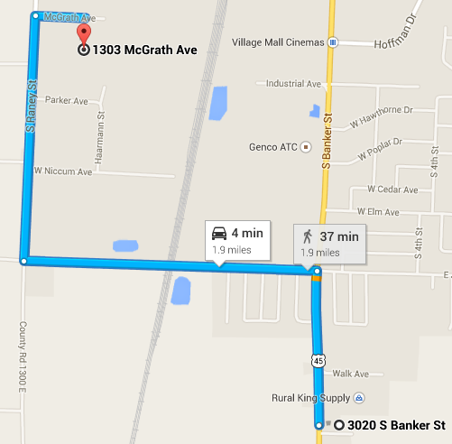

Turn Right (North) when you leave our facility onto South Banker St.

Go to the first stoplight (by McDonalds) – turn Left (West) onto Jaycee Ave.

Go over the overpass to the first stop sign. Turn Right (North) onto Raney St.

Turn right (East) on the third road on the right onto McGrath Ave.

Pyramid Granite Countertop Shop is on the right.

1303 McGrath Ave

Effingham, IL 62401

217-342-2001

